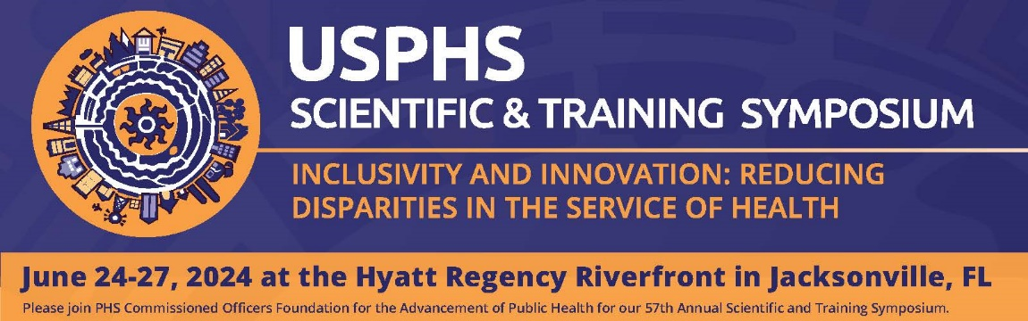
CALL FOR ABSTRACTS
The USPHS Scientific & Training Symposium’s Scientific Track Sessions focus on the measurable impacts achieved by USPHS Commissioned Corps officers and our public health partners and how these efforts protect, promote, and advance the health and safety of our nation.
Abstract submissions of original research, education, practice, policy changes, program evaluation, case studies, and development of guidance or recommendations are welcome.
The Symposium’s scientific track sessions are distinct in that selected presentations must demonstrate adherence to scientific methodology. While any topic relevant to the Symposium theme is welcome, all submitted abstracts must include a background section, structured methodology, clear results (or lessons learned), and conclusions or recommendations for future policy, programs, clinical practice, or research. Abstracts will be scored lower if any of these key components are missing or incomplete. For further guidance, please refer to the Frequently Asked Questions (FAQ): Writing Effective Scientific Abstracts for the USPHS Symposium document.
The following criteria will be used to review abstracts:
- Quality of learning objectives
- Implications/conclusions for public health policy/program/research/practice
- Program or research innovation/originality
- Overall clarity and scientific rigor of abstract

Recommended word count limits:
- Background/Problem (100 words)
- Methods/Project or Program Description (200 words)
- Results/Lessons Learned (200 words)
- Conclusions/Recommendations (100 words)

Authors must include three learning objectives related to their abstract. Objectives should be correctly structured and tied to the content of the description/narrative summary. The following tips are recommended to develop strong learning objectives:
- Identify important concepts you want the audience to acquire from the presentation.
- Begin with a measurable action verb (e.g., describe, assess, explain, develop, analyze).
- Use only one action verb per objective.

Authors must also include three keywords related to their abstract. Keywords will be used to group similar presentations into the 6 tracks described below. Both civilian authors and USPHS officers must receive necessary clearances (e.g., organizational, agency, tribal) before abstract submission. All USPHS officers must also be basic ready to present at the Symposium.
Accepted presenters will be assigned a 30-minute time slot, which includes time for questions and discussion. Presenters are required to use PowerPoint slides to accompany their oral presentations. Each presentation is limited to two presenters. Submission of an abstract constitutes a commitment by the author(s) to register and attend the Symposium.
Please note that the Scientific Track Session call for abstracts is separate from Category Day and pre-conference presentations. Duplicate submissions may not be accepted.
The deadline for abstract submissions is December 4, 2023.
If you have any technical issues or questions about the abstract submission process, please contact: symposium@phscof.org.
Track 1: Clinical Care Career Pathway
Submissions can highlight primary care, specialized care, or clinical management. Examples may include operating in underserved, vulnerable, hazardous, and/or isolated duty locations; incorporating emerging technologies in care delivery; implementing quality improvement projects.
Track 2: Applied Public Health Career Pathway
Submissions can highlight policy; outreach, education, and communication; data analytics, program design, and management; or environmental quality. Examples may include implementing or monitoring laws, policies, or regulations that sustain or promote positive health outcomes; imparting health, programmatic, or intervention information to specific populations; conducting studies involving epidemiology, biostatistics and data analysis on disease or injury patterns; leading initiatives focused on reducing exposures to environmental factors that negatively impact health.
Track 3: National Security Career Pathway
Submissions can highlight domestic or global health security; research and policy; preparedness and response; compliance; or fundamentals. Examples may include collaborating across states or international boundaries with countries, agencies, and organizations to solve problems or promote solutions that protect physical or environmental health; developing evidence-based policy to avoid or solve health security risks; developing public health systems to prepare for and respond to major threats and emergencies; assisting organizations to comply with laws, policies, and regulations.
Track 4: Health Strategy and Innovation Career Pathway
Submissions can highlight research, development, and innovation on health information technology. Examples may include research on how health information technology can improve the quality of healthcare; evaluating new or improved models of practice; designing digital systems and devices to drive health strategy.
Track 5: Inclusivity + Innovation: reducing disparities in the service of health
This track focuses on the 2024 USPHS Symposium theme. Examples may include encouraging innovation in sharing, modeling, and reinforcing best practices; ensuring all communities have opportunities to be protected, and their health and safety needs met; identifying health impacts across the diverse communities and environments that we serve; addressing elements of social determinants of health and any intrinsic biases that have implications for public health, health care, and biodefense preparedness.
Track 6: Public Health in Action
Submissions that do not align with one of the USPHS Career Pathways (Tracks 1-4) or the Symposium theme (Track 5) are still encouraged to be submitted if they encompass public health in action.

